

East West University

Department of Computer Science and Engineering (CSE)

Semester: (Summer, Year: 2025),

B.Sc. in CSE



**LAB 02**



Course Title: Internet of Things

Course Code:CSE 406

Section:01

| Students Details  Name:Seendid Saleh Kabir  ID: 2022-1-60-122 | Course Teacher’s Name:  Dr. Raihan Ul Islam  Associate Professor  Department of Computer Science & Engineering |
| --- | --- |

Submission Date: 30/6/25

**Overview:**

Today's project was based on water sensors and using them to detect water levels and warn others. Basically we had to detect the levels of water and based on the values we have to turn on lights low for green, medium yellow and high for red led lights.

Equipements:Arduino, bread board, wires male to male and male to female, water sensor, led lights and resistors.

Process:

First we take the arduino and connect it with the sensor. The signal pin will go to any analog port(A0) in the arduino as we get analog signals from the sensor. We also connect the Vcc and the Gnd port with the (+) and the (-) pin in the sensor.

Then we connect the led and the process is like this

* 1. First make sure that the Arduino is powered off (no USB cable plugged to anything).
  2. Check the LED, one of the leg is shorter than the other one.
  3. Plug the shorter leg of the LED to a hole on the breadboard. Connect that leg to a GND pin of the Arduino, using a cable.
  4. Plug the longer leg of the LED to a different hole, on a different and independent line of the breadboard.
  5. Add a 220 Ohm resistor between this longer leg and a digital pin of the Arduino, using an additional wire.
  6. This process has to be done for all 3 led lights Green, Red and Yellow.
  7. 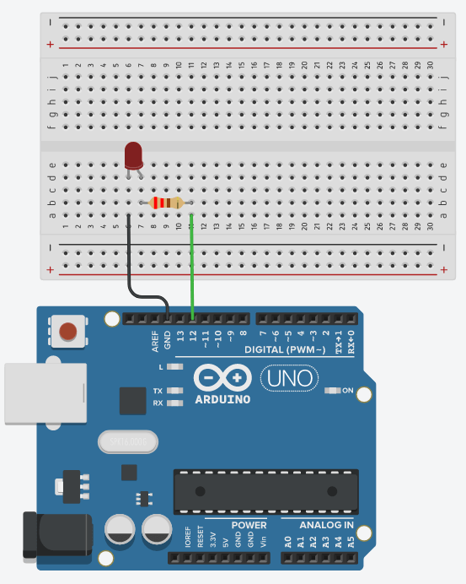

3.Now we need to connect the arduino with them all. We connect the red light with the digital port in the arduino 13, the yellow light with the digital port 12 and the green with 8.

4. Code:

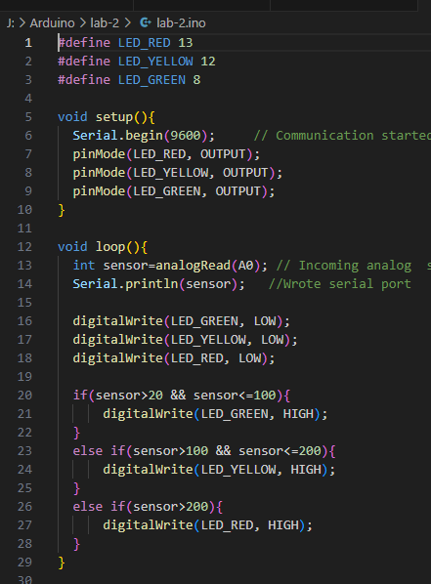

Here we have to first define where we are getting the light signals in the arduino. After that we have to set up our baud configure the LED pins as output. After that in void loop() we are reading the analog signals from the arduino device and displaying it in the serial monitor. We turn off all the lights first and based on the sensor value that we get we are lighting up each light of our choice.

Conclusion:

After finishing all this process one should be able to indicate the sensor value of water from the arduino. Our group final result looked something like below. It was able to light up the led lights based on the sensor value and worked correctly.

